Plate Method Meal Planning
One hour of planning & shopping saves time all week!

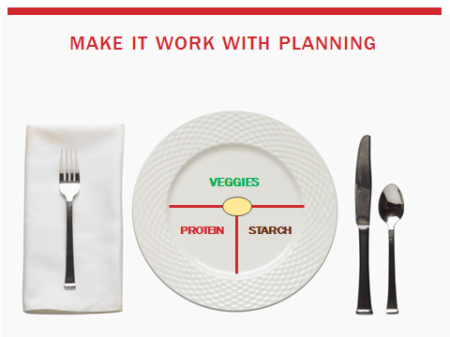

Set a weekly time to get the whole family involved in meal planning. Kids that are involved in cooking, shopping, and planning are often more adventurous eaters.

Our weekly meal planning meeting day & time will be _____________________________.
Think about the basics of a complete meal.
- Protein-rich foods: meats, eggs, fish, Greek yogurt, and beans.
- Vegetables: variety is best. The different colors of vegetables mean you are getting different nutrients.
- Fruit/starch: fruits, potatoes, brown rice, quinoa, whole grain tortillas, bread, pasta.
- Fats: olive oil, nuts, avocado, butter, sour cream. Fats are important for health & satiety.
Give everybody in your family a different colored index card. Each person can fill in what meal they would like for the week. See example below.

Compile the meal choices and make a plan for dinners this week.
Sunday Monday Tuesday Wednesday Thursday Friday Saturday
_______ ________ ________ __________ _________ _______ __________
_______ ________ ________ __________ _________ _______ __________
_______ ________ ________ __________ _________ _______ __________

Now you’ve got a plan! Don’t forget to incorporate leftovers for lunches or dinners the next night. Enjoy!

